Rule Matrix – Maker Checker

  - List View – Search Screen

    - Maker Selection Criteria:
The user can view all the records in the query screen. The records displayed in the query screen will depend upon the search criteria entered by the user. Also the user can query the records without providing any search criteria.

Before Query the screen looks like as under
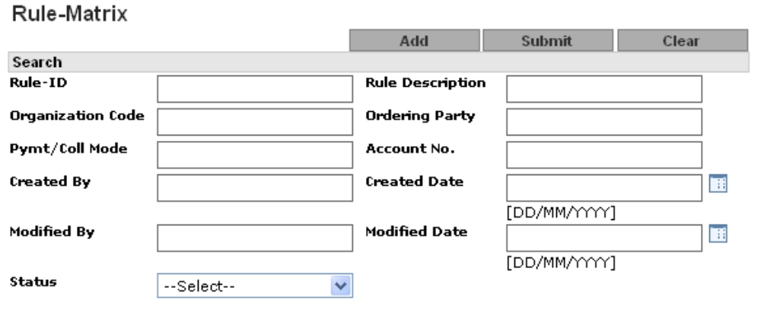

Field Description

Parameter Name | Data-Type | Mandatory/Optional/Conditional | Enable | Insert Allowed | Update Allowed | Field Type | Description
Rule-ID | N | O | Y | Y | N | Text Field | User can enter free text for Rule ID.  Rule ID should be numeric.
Rule Description | A(25) | O | Y | Y | N | Text Field | User can enter free text for Rule Description.  Rule Description cannot contain special characters.
Organization Code | A(8) | O | Y | Y | N | Text Field | User can enter free text for Organization Code.  Organization Code cannot contain special characters.
Ordering Party | A(30) | O | Y | Y | N | Text Field | User can enter free text for Ordering party.  Ordering Party cannot contain special characters.
Account No. | A(15) | O | Y | Y | N | Text Field | User can enter free text for Account No.  Account No. should be numeric.
Payment/Collection Mode | A(30) | O | Y | Y | N | Text Field | User can enter free text for Payment/Collection  Mode.  Payment/Collection Mode cannot contain special characters.
Created By | A(21) | O | Y | Y | N | Text Field | User can enter free text for created by.  Created By cannot contain special characters.
Created date | D | O | Y | Y | N | Popup | Created Date format should be DD/MM/YYYY.
Modified By | A(21) | O | Y | Y | N | Text Field | User can enter free text for Modified by name.  Modified By cannot contain special characters.
Modified date | D | O | Y | Y | N | Popup | Modified Date format should be DD/MM/YYYY.
Block/Unblock | A(15) | O | Y | N | N | Drop down | User can search the Block/Unblock group
Active/Inactive | A(15) | O | Y | N | N | Drop down | User can search the Active/Inactive group
Status | A(15) | O | Y | N | N | Drop down | User can select Status:  - Authorized  - Modified  - New  - Deleted  - Modification Rejected  - New Rejected  - Deletion Rejected

    - User Maker Select List Criteria: After query (After clicking submit button) the screen will looks like as under:
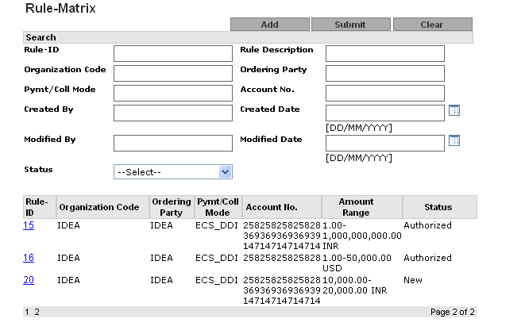

Field Description of the list view

Seq Number | Field Name | Description
1 | Rule Id | This will be the hyper link. While clicking on this Hyper—Link, user can view the existing Rule’s details and then can perform further action on that record  Like: Modify, Delete.
2 | Organization code | Organization Code
3 | Ordering Party | Ordering Party
4 | Payment Mode | Product Code for which mapping is defined.
5 | Account No | Account No
6 | Amount Range | Amount Range
7 | Status | Record status

User can click on the hyperlink of Rule Id to go to View Mode. (Refer view Mode below for functionality)

  - Rule Matrix Maker View

After executing query, user can click on the Rule ID hyperlink to go to Rule Matrix (View Mode). In View Mode the user can only view the details of the record created. There is no other change allowed.

View screen looks like as under

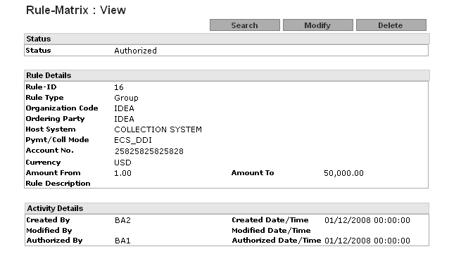
This screen has three parts as:
1. Status
2. Rule Details
3. Activity Details

Field Description

Status

Sr No. | Field Name | Field Type | Description
1 | Status | Label | Display the current status of Group Like authorized, New etc.

Rule Details

Sr No. | Field Name | Field Type | Description
1 | Rule Id | Label | Display Rule ID
2 | Rule Type | Label | Display Rule Type like Group, Group and Auth. Matrix
3 | Organization Code | Label | Display Organization Code
4 | Ordering Party | Label | Display Ordering party for organization.
5 | Host system | Label | Display Host System like payment, collection.
6 | Payment Mode | Label | Display payment and collection mode.
7 | Account No | Label | Display Account number
8 | Currency | Label | Display Currency
9 | Amount From | Label | Display Amount From
10 | Amount To | Label | Display Amount To
11 | Rule Description | Label | Display Rule Description

Activity Details

Sr No. | Field Name | Field Type | Description
1 | Created By | Label | Created by Login ID
2 | Created date /Time | Label | Created on date time
3 | Modified By | Label | Modified by Login ID
4 | Modified date/Time | Label | Modified on date time
5 | Authorize By | Label | Authorize by Login ID
6 | Authorize Date/Time | Label | Authorize on date time

